#### Environment:

System: Windows 10

IDE: Android Studio, VSCode and AVD Manger

Language: Dart

#### Setup the Dart and Flutter environment

* [Flutter official website to download the installation package Flutter SDK](https://flutter.io/docs/development/tools/sdk/archive?tab=windows#windows)
* 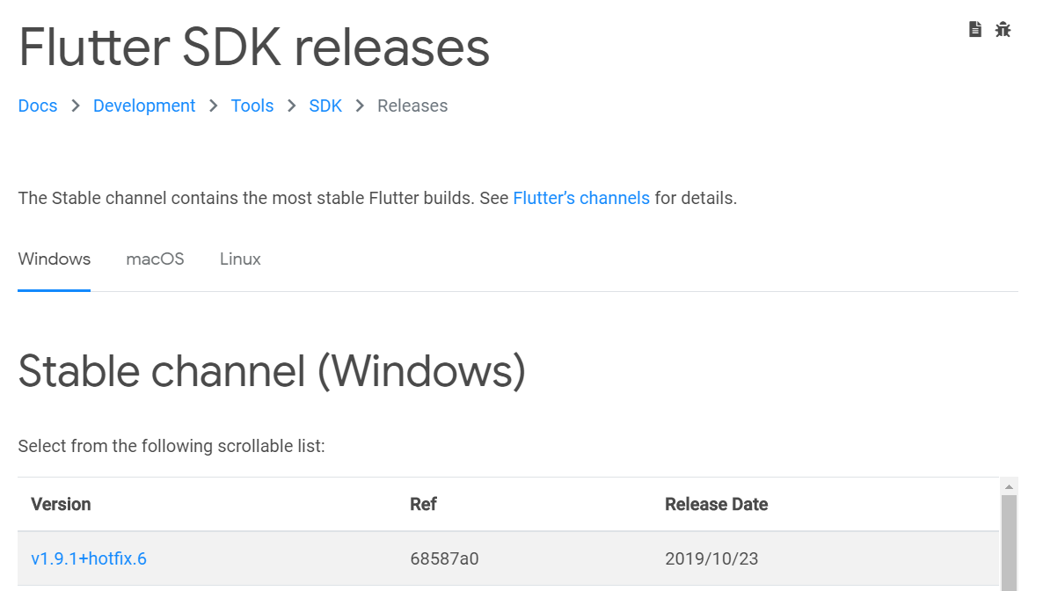
* The Dart SDK is already bundled with the Flutter SDK, so there is no need to install the Dart SDK separately.
* Unzip the downloaded installation package to the path where you want to install the Flutter SDK (eg D:\flutter, be careful not to install flutter to a path that requires some high privileges such as C:\Program Files)
* Locate flutter_console.bat under the flutter file in the Flutter installation directory. Double-click it to start the flutter command line automatically.

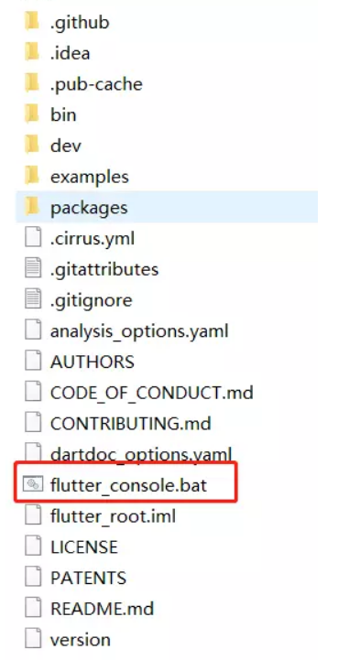

##### Change system environment variables

* Open Control Panel > User Accounts > User Accounts > Change My Environment Variables
* Add Flutter to it.

##### Flutter doctor test

Terminal input: flutter doctor

This command checks your environment and displays the report in a terminal window. This command may run very slowly for the first time. Flutter automatically installs the required dependencies and compiles them.

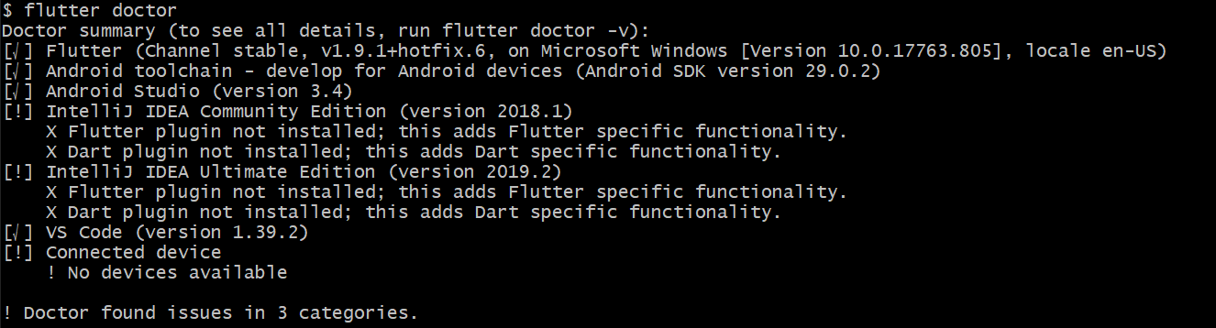

##### Install Android Studio and create an emulator (AVD virtual machine)

[Official website to download the installation package](https://developer.android.com/)

##### Android Studio installs the Flatter plugin

Open Android Studio, menu bar File => Settings => Plugins, enter futtler in the search box, click install, after the installation is complete, restart Android Studio.

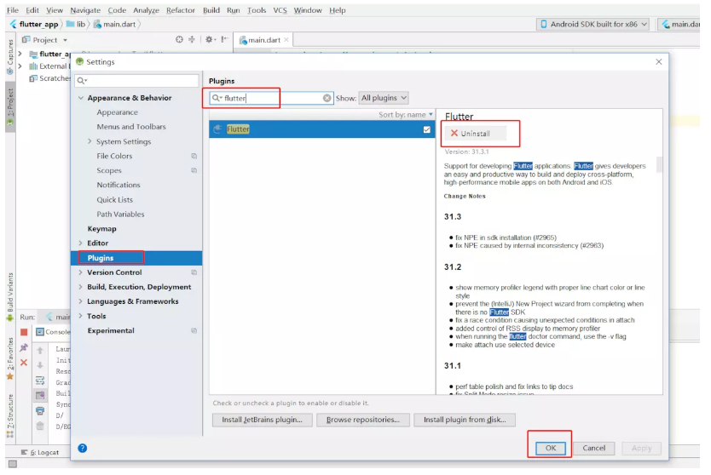

##### Install Android certificate

Terminal input: flutter doctor --android-licenses

Note: Tips are always entered y

#### Running Flutter

1. Open Android Studio, menu bar File => New => New Flutter Project, select the first option Flutter Application (flutter application)

* 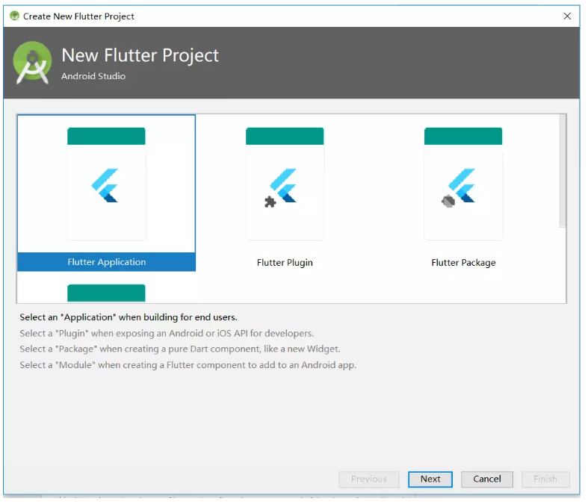
* Enter the project name (note: the project name must be lowercase, the words are separated by underscores), always click next, and finally finish, the system can automatically create a Flutter project.
* 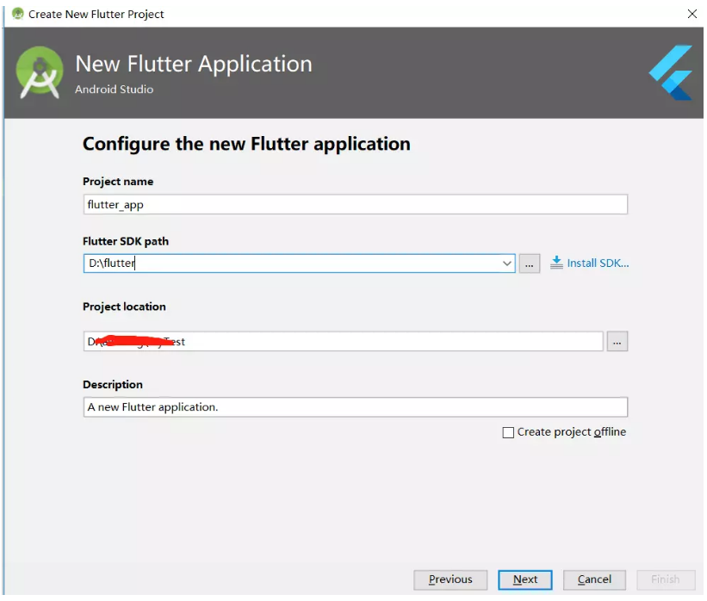

1. In the open Android Studio you can see the Flutter project created in the previous step.

* 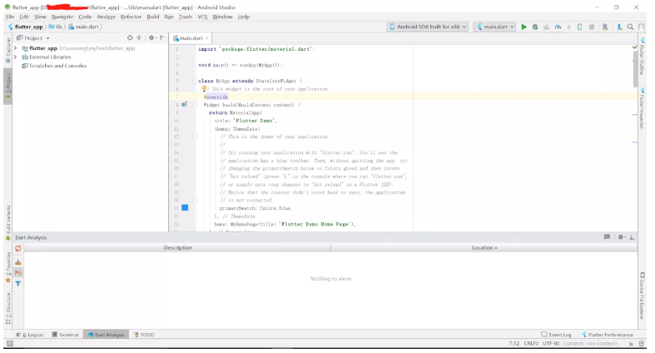

1. Turn on the emulator (ADV Manager icon button in the upper right corner)

* 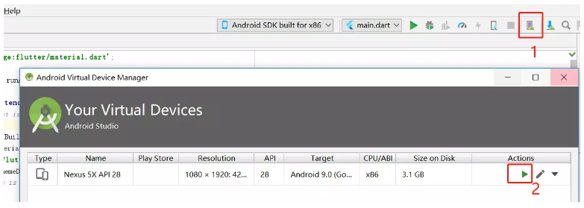

1. Once the emulator is running, click the debug or run icon button in the top right corner of Android Studio. (This step takes a little time, pay attention to observe the console area information, as shown below, the compilation is successful)

* 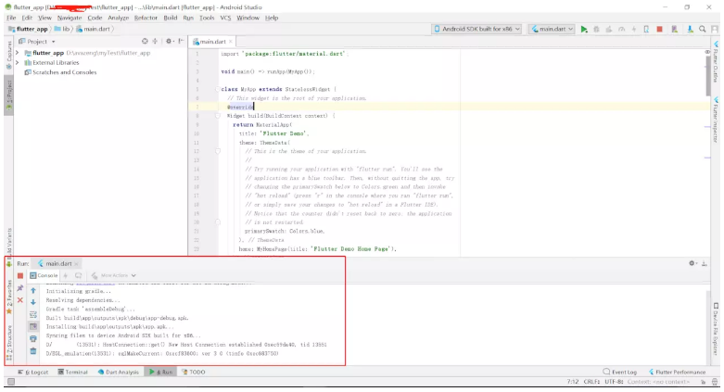

1. After the previous step is successfully compiled, you can see the flutter application page in the emulator.